Efficiently displaying and zooming/panning large images in WPF
up vote4down votefavorite | I'm currently working on an application with the need to display large engineering drawings that can be 8800x6800 or larger. The requirements state that the user should be able to pan and zoom the image. Ideally, they'd like to be able to annotate the images as well. If you look at the Windows Photo Viewer, you'll see the performance and features I'm looking to emulate, minus the annotation part.  So far, I've tried a couple different approaches for displaying the images and none seem to offer the performance that I'm looking for. Either they take up a lot of memory or they're slow. These are the approaches I've taken:  - Viewbox with the Image as a child. Memory usage is OK, but re-sizing the Viewbox is slow. I haven't tried zooming/panning with this approach yet because of that.  - InkCanvas with the Image set either as the background or as a child. With this approach zooming/panning by way of ScaleTransform and TranslateTransform seemed so-so, but memory usage could be up in the 450-600 MB range.  This is my first foray into image manipulation with .NET/WPF and my knowledge on the subject is fairly limited. What are some best-practices for dealing with large images, especially with WPF? I've read that tiling the image (like deep zoom) can help, but was unsure on how to do this or if it's the best idea in my situation. Do you know of any resources that might help me understand this better?  c# wpf zoom imaging pan
  shareimprove this question | asked Apr 14 '11 at 13:11    Steve Platz  82131521
Did you solve this problem in the end? – Phil Applegate Apr 30 '13 at 11:01
add a comment

1 Answer
activeoldestvotes
up vote1down vote | By "tiling" if you mean splitting the image up into separate pieces and only displaying a small subset at once to improve performance, this would be called "virtualisation".  Microsoft has an excellent blog about virtualising items and even provides a reference implementation of a VirtualCanvas which you can use as the starting point for a virtualised control.  Link here: http://blogs.msdn.com/b/jgoldb/archive/2008/03/08/performant-virtualized-wpf-canvas.aspx  Note that this blog includes zoom and scale as part of the discussion as well as a discussion about smooth scrolling and pre-emptive loading of tiles for best UI responsiveness.
  shareimprove this answer | answ

As you may already know WPF has a built-in virtualizing panel called VirtualizingStackPanel that supports UI virtualization and lays out its elements like StackPanel.
The WPF ListBox & ListView controls use this panel by default. Other containers controls such as Canvas do not have virtualization support in .Net 3.0 & 3.5.
Chris Lovett from Microsoft now wrote a great sample that shows how you can also virtualize a Canvas container control so it can efficiently host and scroll thousands of WPF elements without consuming huge amount of memory.
The provided down-loadable ZIP has a white paper and the code.
Hope you find this useful.
Jossef.
VirtualCanvas.zip
Tags Virtual Canvas WPF Virtualization

A Simple Virtual Canvas
By Chris Lovett

If you try and create 10,000 shapes and add them to a WPF Canvas it will probably take a while and consume a lot of memory. But for a large canvas inside a ScrollViewer, you rarely zoom out to view all of those shapes at once, so wouldn’t it be nice if we had a VirtualCanvas that could dynamically create only those shapes that are in the visible region of the ScrollViewer.

Well, it’s pretty hard to do that in a general purpose way, but if we make some simplifying assumptions, then we can make it pretty easy. If we assume each shape on the canvas has a fixed Rectangular bounds that is not animating all over the place, then we can create a virtual canvas pretty easily and this is exactly what I’ve done so I thought I’d share it with you. I found this to be very useful when building a canvas that contains a big graph of nodes and edges, but it’s not limited to any particular type of content, for example, you could use it for virtual trees or grids as well.

Before building the VirtualCanvas I first read BenCon’s excellent tutorial on implementing IScrollInfo, and added this functionality so the VirtualCanvas behaves properly when placed inside a ScrollViewer as follows:

<ScrollViewer x:Name="Scroller"
HorizontalScrollBarVisibility="Auto"
VerticalScrollBarVisibility="Auto"
CanContentScroll="True">
<my:VirtualCanvas x:Name="Graph" />
</ScrollViewer>

So how does it work? Well, first I created a new interface called IVirtualChild which encapsulates the simplifying assumption of the shape having a static rectangular bounds, and it provides other minimal information needed to make the VirtualCanvas work. In my sample app I implemented this interface on a class named TestShape. Then my sample code adds a whole bunch of random shapes by doing something like this:

Rect bounds = new Rect(pos, s);
TestShape shape = new TestShape(bound, TestShapeType.Ellipse, r);
canvas.AddVirtualChild(shape);

and the result is the following:

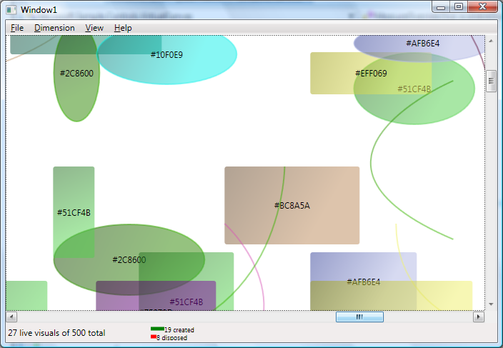

Notice the sample is not calling Canvas.Children.Add(). The VirtualCanvas does this lazily. The IVirtualChild interface is pretty simple, it has the following members:

/// <summary>
/// This interface is implemented by the objects that you want to put in the VirtualCanvas.
/// </summary>
public interface IVirtualChild
{
/// <summary>
/// The bounds of your child object
/// </summary>
Rect Bounds { get; }

/// <summary>
/// Raise this event if the Bounds changes.
/// </summary>
event EventHandler BoundsChanged;

/// <summary>
/// Return the current Visual or null if it has not been created yet.
/// </summary>
UIElement Visual { get; }

/// <summary>
/// Create the WPF visual for this object.
/// </summary>
/// <param name="parent">The canvas that is calling this method</param>
/// <returns>The visual that can be displayed</returns>
UIElement CreateVisual(VirtualCanvas parent);

/// <summary>
/// Dispose the WPF visual for this object.
/// </summary>
void DisposeVisual();
}

Notice that your virtual child object can be very light weight – all it needs to provide is a bounds so the VirtualCanvas can figure out when it needs to actually create the WPF visual for it. This means creating 10,000 of your IVirtualChild objects should be very fast. I can create 10,000 TestShapes on my machine in under 1 second because it doesn’t create any WPF objects until CreateVisual is called.

The following shows a simple implementation of the IVirtualCanvas interface:

class VirtualEllipse : IVirtualChild
{
Rect _bounds;
UIElement _visual;

public event EventHandler BoundsChanged;

public VirtualEllipse(Rect bounds)
{
_bounds = bounds;
}

public Rect Bounds
{
get { return _bounds; }
}

public UIElement Visual
{
get { return _visual; }
}

public UIElement CreateVisual(VirtualCanvas parent)
{
if (_visual == null)
{
Ellipse e = new Ellipse();
e.Width = _bounds.Width;
e.Height = _bounds.Height;
e.Style = parent.Resources["MyEllipseStyle"] as Style;
_visual = e;
}
return _visual;
}

public void DisposeVisual()
{
_visual = null;
}
}

When the bounds of this VirtualEllipse intersects the visible view port in the ScrollViewer, the CreateVisual method is called and the real WPF ellipse appears. When it scrolls off-screen the VirtualCanvas will remove it from the canvas and call DestroyVisual() to cleanup this object so the garbage collector can reclaim the memory. So in scrolling around the VirtualCanvas many calls to CreateVisual and DestroyVisual will be made. The sample code provided with this article shows a little animation of this creation/destroy process in the status bar so you can see how much activity happens as you scroll around. The screen shot below shows that there are 111 actual live WPF visuals, and 71 were just created while 82 where disposed.

The sample application I built to show off the VirtualCanvas also contains zooming, panning, and auto-scroll gestures so you can zoom and pan all day to get a feel for the VirtualCanvas performance. I think you will find that the performance is almost as good as if all the WPF objects were already created, unless you zoom out a ways, then you will start to see the delay in creating WPF objects and the app will slow down and if you page up and down you will briefly see white before the shapes show up. This is the price you pay for virtualization. Page up/down/left/right is the degenerate case because every shape has to be destroyed and all new shapes have to be created for the new page you are viewing. If you scroll by a line or pan by a few pixels then you will see smoother performance.

Now the VirtualCanvas tries not to hang the UI in this case by “lazily” creating the visuals in chunks, if you zoom out far enough you will start to see this effect which blocks of visuals showing up as it lazily creates them.

So how does it work?

The implementation of the VirtualCanvas is based on a simple QuadTree data structure that makes it possible for the VirtualCanvas to answer the question “GetChildrenIntersecting(Rect bounds)” efficiently so as we scroll we can quickly figure out which visuals need to be created and which ones need to be destroyed. The QuadTree does this by subdividing the entire “Extent” of the VirtualChildren into a recursive tree of Quadrants (top left, top right, bottom left, bottom right), recursively as follows:

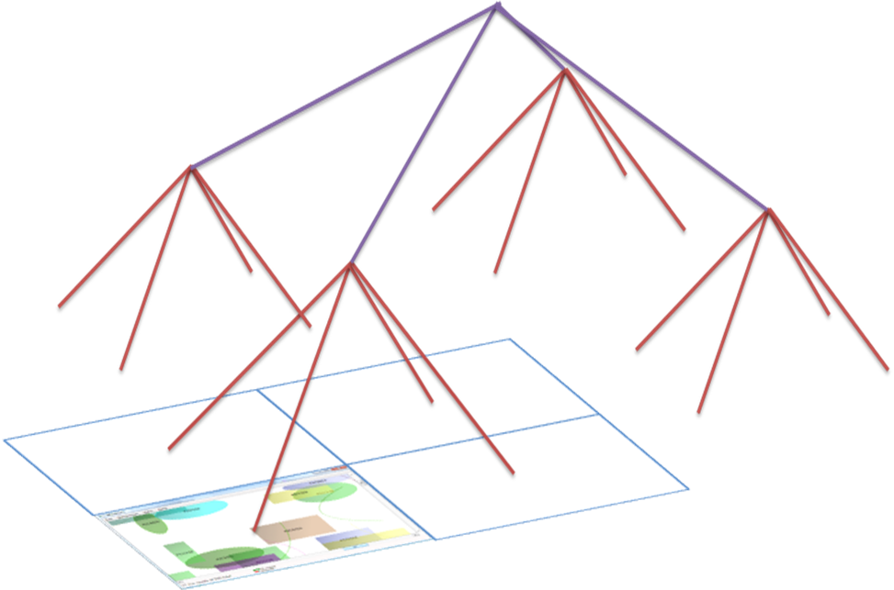

This picture is over simplified since the current view port doesn’t necessarily coincide with one branch of the QuadTree, but it should give you the general idea. Maintaining this QuadTree takes time, so animating lots of shapes would be more expensive than normal using this design since it will have to remove the animating shapes from their old Quadrant in the QuadTree and find their new Quadrant on every movement.

One more trick is that you would normally expect the order in which you call AddVirtualChild to be maintained in the actual Visual child order, otherwise scrolling could causing Visuals to jump on top of other Visuals and vice versa which would be highly unusable. So the VirtualCanvas makes sure those Visuals are always inserted in the same order as the AddVirtualChild calls no matter how and when they are actually created and destroyed.

Conclusion
There is clearly a lot of additional things you could do beyond this to improve scalability. For example you could gracefully remove detail as you zoom out, dropping unreadable text labels for instance. You could also cache redundant shapes in Bitmaps to get more scalability that way. Another trick if you know more about your specific application domain is to recycle shapes when DisposeVisual is called, instead of just throwing them to the garbage collector, this could greatly improve page up/page down performance in a big canvas if you can reuse a lot of shapes.

Hopefully you find the sample proves that this technique is interesting and can result in a usable virtual canvas that can handle a lot more shapes that WPF would normally be happy with.

